Use cases
1 Acronyms 3
2 Introduction 4
3 Use Case 01 – Overtake 5
3.1 Use Case Goals 5
3.2 Requirements / Pre-conditions 5
3.3 Sub-scenario(s) 5
3.3.1 Simple overtaking – cooperation between an SV and a TV 6
3.4 Challenges 7
3.5 Design of Human Machine Interfaces (HMI) 8
3.6 Functionalities/Steps (UNDER SPECIFICATION) 10
4 Use Case 02 – Pedestrian safety at crosswalks 11
4.1 Requirements / Pre-conditions 11
4.1.1 Crossing a road (UC-B2 – ITS 103 300 – 1) 11
4.1.2 Signalling a hidden VRU (UC-C1 – ITS 103 300 – 1) 11
4.1.3 Non-Equipped VRU crossing the road (UC-D2 – ITS 103 300 – 1) 12
4.2 Sub-Scenarios(s) 12
4.2.1 Crossing a road (UC-B2 – ITS 103 300 – 1) 12
4.2.2 Signalling a hidden VRU (UC-C1 – ITS 103 300 – 1) 13
4.2.3 Non-Equipped VRU crossing the road (UC-D2 – ITS 103 300 – 1) 13
4.3 Challenges 14
4.4 Interfaces (HMI ) 14
4.4.1 Crossing a road (UC-B2 – ITS 103 300 – 1) 14
4.5 Goals 15
4.6 Functionalities/Steps 15
5 Technologies/Standards 16
5.1 In use cases 16
5.1.1 Use Case 1 specific 16
5.1.2 Use Case 2 specific 16
5.2 Cooperative Awareness Messages (CAM) 16
5.3 Decentralized Environmental Notification Message (DENM) 16
5.4 VAM - Vulnerable Road Users Awareness Message 17
5.5 Issues in Associated technologies/use case 17
5.5.1 Issues with MCM 17
6 Information Exchanged 18
6.1 MCM Container 19
6.2 Advised Manoeuvre Strategy Container 22
6.3 VAM related information 23
7 Security Aspects 25
7.1 Generic Threat Model(s) 25
7.2 Use Case 1 – Threat Model 26
7.3 Use Case 2 – Threat Model 26
8 References: 28
Annex A – Use Case 01 Settings on ETSI TS 103 561 29
TS-103-561 documented manoeuvres 29
Temporarily disband an existing group 29
Spiral path and mountainous roads 30
Annex B – Identifiers in vehicles 31

Acronyms

DENM - Decentralized Environmental Notification Messages.
CPM – Cooperative Perception Message
CAM – Cooperative Awareness Message

ITS - Intelligent Transport Systems
MCM - Manoeuvre Cooperative Message
MCS - MCM Manoeuvre Coordination Service
RSE – Road Side Equipment
RSU – Road Side Unit
VAM - Vulnerable Road Users Awareness Message
V-ITS-S – Vehicle XXX
VRU – Vulnerable Road User
VRU-St – Vulnerable Road User with ITS Station

Introduction
ADSafeVANET considers two complementary use cases:
- UC1-Overtaking (V2V collaboration)
- UC2- Pedestrian safety at crosswalks (V2X communications)

Use Case 01 – Overtake
This use case relies on the Manoeuvre Coordination Service (MCS) draft specification ETSI TS 103 561 release 2 (2025). The use case considers security and functional aspects from the MCM specification.

Use Case Goals
- Integrate the final specification of MCM Manoeuvre Cooperative Message
- Enhance on the information is presented in the human driven vehicle (TV)

Requirements / Pre-conditions
The Pre-conditions of the use case consider:
- A Autonomous vehicle that wants to perform the overtaking – Subject Vehicle (SV)
- A Connected Vehicle that is the Target Vehicle (TV):
  - will be overtaken
  - is driven by a human

Both Vehicles SV and TV support MCS and use MCS messages to signal the overtaking manoeuvre:
- MCM Manoeuvre strategy Type Traffic – Overtaking with Coding=00001000 (table 9 [TS-103-561]

Sub-scenario(s)
Possible scenarios:
- Simple overtaking – cooperation between an SV and a TV
  - TV maintains the velocity – Requires the human driver to acknowledge the manoeuvre.
  - TV does not want to be overtaking -- Requires the human driver to acknowledge that he does not want to be overtaken.
  - TV reduces the velocity to facilitate manoeuvre – Requires a decision from the human driver. E.g., reduce from 50 km/h to 40 km/h.
    - There is a renegotiation making new exchange of MCM messages which can include slowdown.
    - TV accepts the manoeuvre and makes a suggestion for a new trajectory (reduced velocity) WORK ON THE POSSIBLE SOLUTIONS/ALTERNATIVES
  - SV may cancel the manoeuvre
  - The SV does not follow the predicted trajectory which implies an action on the human driver –
    - Misbehaviour from autonomous vehicle

- Overtaking in highway – cooperation between an SV and multiple TVs
  - TVx take an alternative lane/trajectory
  - TV increases velocity

- As per TS-103-561 - Temporarily disband an existing group

Simple overtaking – cooperation between an SV and a TV

The first sub-scenario to consider is a simple overtaking, where a SV aims to perform this manoeuvre. The scenario is depicted in Figure 1 and includes the following generic steps:
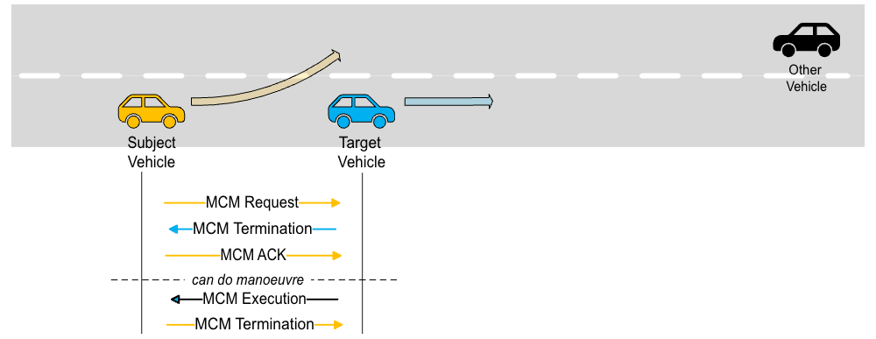

Figure 1 - Scenario of simple overtaking

- SV sends a MCM Request message to signal the intention to overtake at instant t.
- TV receives the MCM Request and sends a MCM Response to acknowledge the intention for overtaking.
- SV acknowledges the manoeuvre knowledge from the target vehicle (assuring that all are synchronized), this acknowledgment is performed through a MCM ACK (a proposed extension to the MCM specification),
- The manoeuvre can be executed, since both vehicles are aware of the manoeuvre that will be performed.
- The TV sends a message MCM Execution, for the execution of the manoeuvre.
- The SV sends a message to confirm the conclusion of the overtaking, by sending a MCM Termination message.

Challenges

- How does MCS works with multiple interfaces/technologies? For instance, if intent is sent within an interface?

MCS through 5G
Vehicle starting the MCS intent on one interface and concluding in another interface
SV supporting multiple techs.

- How to present the manoeuvre intention to the TV(s)?
  - Reduce distraction
  - Minimize time for approval (if depending on human factor)
    - Be careful with the timeouts for the decision

Important:
- Know the actions
- Know the importance/relevance of the actions
- Default timeouts/SLAs
- Understand HMI – facility
- Matching IDs (How to identify the vehicle that is nearby)
  - Data Fusion
  - No complete framework to do this
    - Interesting having information of the car
    - Interesting of having notifications

Design of Human Machine Interfaces (HMI)

Possible solutions/items:
- Default button with timer (1s)
  - To meet 1s threshold default action ACCEPT Manoeuvre
    - Several retries can be issued to obtain a reply from TV.
- Yes to accept a manoeuvre
- No to refuse the manoeuvre
- Yes and facilitate (reduce 10%) to accept manoeuvre

Approaches to the interfaces:
- 3D view
- Vehicle type (as per basic container field)
- Intended trajectory of the SV
  - GPS coordinates (Latitude, Longitude, and optionally altitude)
  - Other information Temporal and Kinematics characteristics as per Table 5
- Velocity of the SV
- Heading of the SV
- Trajectory of the SV (as per the Target Road Resource – TRR see Table 5)
- SV status
- Timing related with manoeuvre (as per Temporal Characteristics see Table 5)

Split View

Functionalities/Steps (UNDER SPECIFICATION)

Steps:
- Autonomous vehicle informs that wants to overtake
- Connected vehicle receives information
    - How to present the information, coordinates, estimation of the location to perform the manoeuvre)
- Connected vehicle accepts the manoeuvre
- Autonomous vehicle overtakes

Use Case 02 – Pedestrian safety at crosswalks

This use case is already well standardized by ETSI for Vulnerable Road Users (VRUs) (link)
- ITS 103-300-1 – Use Case Definition (link)
- ITS 103-300-2 - Architecture and Requirements (link)
- ITS 103-300-3 – VRU awareness basic service (link)

Possible matches:
- UC-B2: VRU crossing a road (P2V)
- UC-C1: Signalling VRU hidden by an obstacle (V2V)
- UC-D2: Non equipped VRUs crossing a road (I2V)
- UC-D3: VRUs crossing at a zebra protected by a traffic light (seems simple and probably not interesting)

Requirements / Pre-conditions

This use case is specified in several sub-scenarios which have their own requirements and pre-conditions.

Crossing a road (UC-B2 – ITS 103 300 – 1)

- The Vulnerable Road User (VRU) has an ITS Station (VRU-St), being able to receive and transmit ITS messages
  - Only focus on the interfaces of the Vehicle
- The VRU performs risk assessment, it can identify risk situations
  - Reuse existing ‘Risk information’ for collision
- There is at least a vehicle V-ITS-S that can process ITS messages.

Signalling a hidden VRU (UC-C1 – ITS 103 300 – 1)

- The Vulnerable Road User (VRU) has not any ITS Station (VRU), thus is not able to receive and transmit ITS messages.
- There is a V-ITS-S equipped with a camera/or sensor that can detect a VRU and communicate it to another V-ITS-S.
- There is another V-ITS-S that does not see the hidden VRU.

Non-Equipped VRU crossing the road (UC-D2 – ITS 103 300 – 1)

- The Vulnerable Road User (VRU) has not any ITS Station (VRU), thus is not able to receive and transmit ITS messages.
- There is a Road Side Unit/Equipment (RSU/RSE) equipped with a camera/or sensor that can detect a VRU and communicate it to other vehicles
- There is at least one V-ITS-S interacts with the RSU regarding the identified VRU

Sub-Scenarios(s)

Crossing a road (UC-B2 – ITS 103 300 – 1)

This sub-scenario is specified as follows:
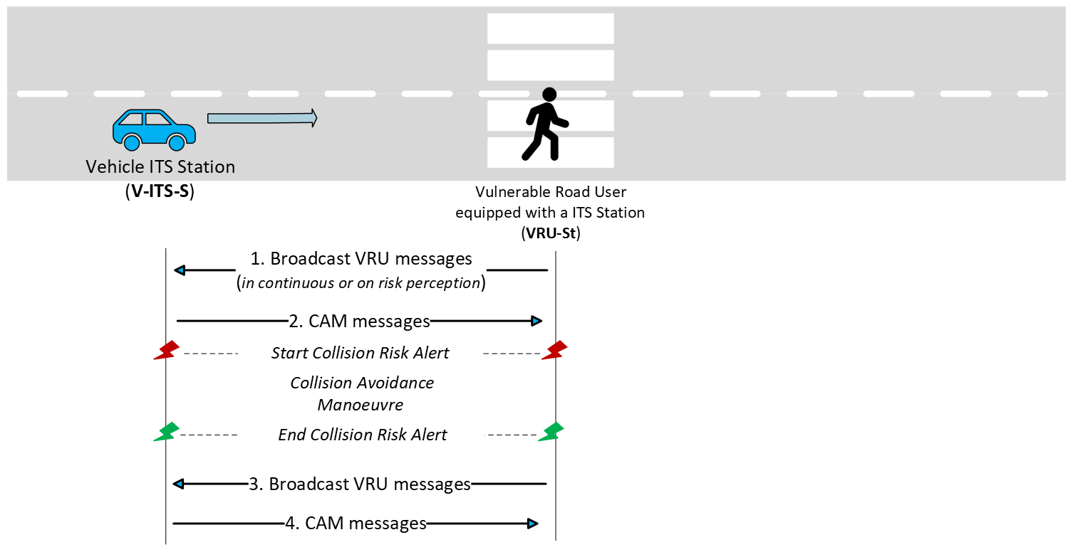
Figure 2 – Pedestrian Safety sub-scenario pedestrian crossing the road (ETSI TS 103 300 - UC-B2)

Signalling a hidden VRU (UC-C1 – ITS 103 300 – 1)

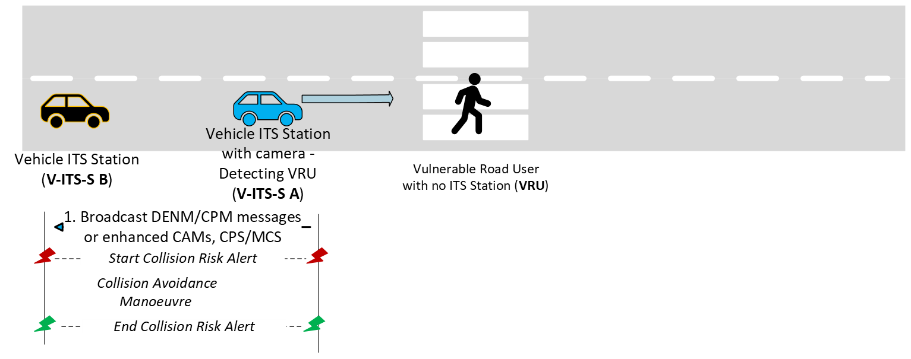
Figure 3 Pedestrian Safety sub-scenario hidden VRU

Non-Equipped VRU crossing the road (UC-D2 – ITS 103 300 – 1)

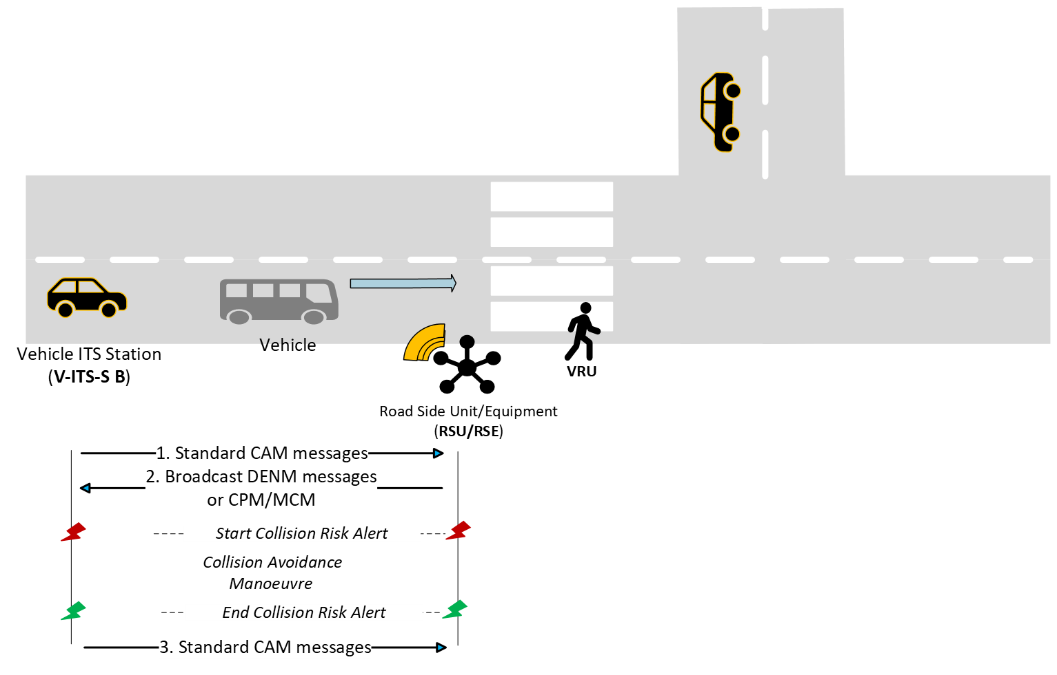
Figure 4 - Pedestrian Safety Non-Equipped VRU sub-scenario

Challenges

- How to present the information of pedestrians to drivers ?!
- How to avoid fake, false messages from pedestrians ?! (Can this occur?!)
?!

Interfaces (HMI )

Crossing a road (UC-B2 – ITS 103 300 – 1)

3D View – consider the interface design of first use case, but representing the pedestrian entity in a different way (safety component)
- Important to know the “intention” of movement of the pedestrians, we don’t need to do nothing on the interface if pedestrian does not want to cross the road.
Represent the pedestrian in the vehicle interface

Other pedestrians that can be detected by the vehicle, alert the driver regarding

Goals

Functionalities/Steps

Technologies/Standards

In use cases

Use Case 1 specific

- MCM (when becoming a final standard)
- Decentralized Environmental Notification Message (DENM
- Cooperative Awareness Messages (CAM)

Use Case 2 specific

- VAM – Vulnerable Road Users Awareness Message

Cooperative Awareness Messages (CAM)
CAM:
- Are broadcasted by vehicle to nearby nodes.
- Include vehicle state information: position, speed, heading, acceleration

Decentralized Environmental Notification Message (DENM)
DENM:
- Are event-driven messages
- To notify other vehicles
- Sent in response to incidents like: accidents, traffic jams, hazardous road conditions
- Supported by VW.

VAM - Vulnerable Road Users Awareness Message

Specified in ITS 103 300-3 standard
The VAM messages contain the following information:
Type | Fields | Description/Note
Status information | Time  Position  Motion State  Cluster Status
Attribute information | VRU Profile  Type  Dimension

VRU Profiles:
- VRU Profile 1 – Pedestrian, VRUs not using a mechanical device for the trip
- VRU Profile 2 – Bicyclist, may include wheelchairs, skaters, e-scooters
- VRU Profile 3 – Motorcyclist, using vehicles powered with two wheels
- VRU Profile 4 – Animals, which represent a safety risk to other road users.

VRU Basic Service (HERE Section 4.2 of ITS 103 300-3)

Issues in Associated technologies/use case

Issues with MCM
- Message loss during maneuver negotiation, may lead to maneuver latency solution already proposed by IT [PaperIT] with ACK mechanism and Relevance Message Detector.

Information Exchanged

Communication protocol can be (as per the profile of the original ITS-S and MCM type):
- Unicast
- FA-Multicast
- FA-Broadcast
- Or general broadcast

Table 1 - Contents per type of message
Message | Header | Contents | Dissemination | Description
MCM Request | ITS PDU Header | Basic Container  MCM Container(s) | Any available communication mode | agreement to start a specific manoeuver
MCM Intent | ITS PDU Header with type =0 | Basic Container |  | can be used for other vehicles to perform an MCS offer (changing trajectory)
MCM Offer | ITS PDU Header | Basic Container | Broadcasted or addressed to one or several vehicles (unicast, FA-multicast) | Provides intended new reference trajectory or Target Road Resources (TRR)  Useful to start a MC negotiation/session
MCM Reservation |  |  |  | Can be used at the Execution phase  It is a request message
MCM Execution status |  |  |  | - Started (0)  - inProgress (1)  - completed (2)  - terminated (3)  - chained (4) chained to a new MC session.

Table 2 - Details of the ITS PDU Header as per ETSI TS 102 894-2
Field | Value | Notes
MCM Protocol Version | 1
MCM type identifier | Message ID | Intent, Request, Response, Termination, Emergency Reservation, Execution Status, Offer
ITS Station Identifier | Station ID | Can be configured but it is not normalized,  it is required to keep the identification during a manoeuvre. VW changes the ID (every couple of hours, random ID probably using (HMAC( from mac address))

Table 3 - Details of the Basic Container
Field | Value | Notes
Generation Delta Time | Timestamp mod 65536 | Integer value in milliseconds since 2004-01-01 as defined ITS 102 894-2
Type of originating ITS-S | - VRU portable device  - Vehicle (vehicle type)  - Roadside unit  - Central station
ITS-S role | - Not available  - Manoeuvre coordinator  - Not-coordinating subject vehicle  - Target Vehicle | - A subject vehicle may have the coordinating role as per the collaborative action  - The role of the originating ITS-S can only be determined when collection action is accepted by all
Latest WGS 84 geographic position |  | - Position of the originating ITS-S at the time of the MCM generation
Vehicle position confidence level |  | - Optional only for vehicles

MCM Container
Provides information of the role and responsibility of the manoeuvre coordination. The contents depend on the originating ITS-S type.
The number of total submanoeuvres per manoeuvre is 8.
Table 4 - Details of the MCM Container
Field | Value | Notes
MCM Type | 1 – MCM Request; 4 - ; 7 - | Intent, Request, Response, Termination, Emergency Reservation, Execution Status, Offer
Manoeuvre ID |  | How is this number set?  Currently based on a counter on the existing IT implementation
Manoeuvre coordination concept |  | Agreement seeking or prescriptive, cooperation cost, prescriptive goal
Manoeuvre coordination Rational |  | Manoeuvre Cooperation Goal  Manoeuvre Cooperation Cost
Manoeuvre coordination status |  | Only for MCM type 4 and 7.
Vehicle current state container (optional) | - Vehicle manoeuvre overall strategy  - Speed  - Heading  - Speed variation  - Size
Number of submanoeuvres to be executed
List of ordered submanoeuvres |  | The list is related with the manoeuvre from the originating vehicle.

Table 5 - Information of each submanoeuvre (TRR, temporal and Kinematic characteristics)
Field | Value | Notes
Submanoeuvre ID |  | CHECK LOGIN IN MANOEUVRE ID?
Sub Manoeuvre Strategy
Reference Trajectory (optional) |  | Of the coordinating vehicle (optional)
Target Road Resource (TRR) | - TRR Type (1,2,3)  - TRR Location  - Shape and Dimensions | TRR for the coordinating vehicle (optional and conditional)
Temporal characteristics to TRR | - Start time prediction  - End time prediction | Conditional to the use of TRR
Kinematic characteristics to TRR | - Minimum speed  - Maximum speed | Conditional to the use of TRR

USE TABLE 9 of Manoeuvre strategies from standard
Table 6 - Information of Traffic submanoeuvre strategy type
Manoeuvre strategy description | Manoeuvre strategy Value | Comments
Overtake | 0000 1000 | Vehicle is signalling that it will overtake or is advised to overtake other vehicle
Accelerate | 0000 1001 | Vehicle is signalling that it is accelerating or is advised to accelerate  This implies a new trajectory TRR, so new values.
Slowdown | 0000 1010 | Vehicle is signalling that it is slowing down or is advised to slow down  This implies a new trajectory TRR, so new values.

Table 7 - Information of Safety submanoeuvre strategy type
Manoeuvre strategy description | Manoeuvre strategy Value | Comments
Stay in Lane | 0100 0010 | The vehicle is signalling that it is remaining in its current lane or is advised to stay in its current lane

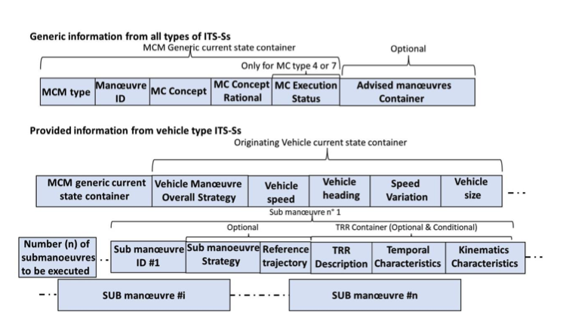
Figure 5 - MCM container with submanoeuvres

Advised Manoeuvre Strategy Container
Can be provided in unicast of FA-Multicast for the identified target vehicles identifiers (ITS-S ID) during the initiation phase.
HOW ARE THE IDS discovered?
WHEN IS DONE THE INITIATION PHASE

Three types of manoeuvre strategies are considered:
- All manoeuvres identified in the traffic type
- All manoeuvres in the safety type
- All manoeuvres in the group manoeuvre

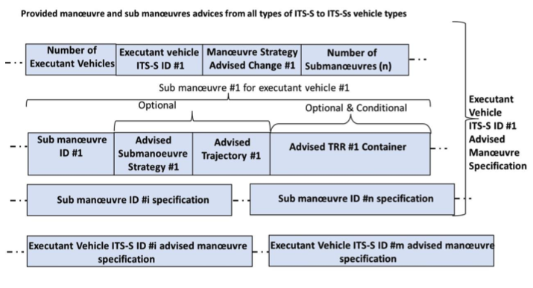
Figure 6 - Sub manoeuvres advice

VAM related information
The information of VAM messages is described in the following table
Table 8 - VAM related information (section 7.1 ITS 103 300-3)
Field | Description
ITS PDU Header | StantionId changes if VRU is part of a cluster or not | As per TS 102 894-2
Generation time | Number of milliseconds (modulo 2¹⁶)
Basic Container | Originating ITS-S type  Geographic Position (includes positionConfidenceEllipse with 95% conf. level) | As per TS 102 894-2
VRU high frequency container with dynamic properties | Heading  Speed  Lane Position  Acceleration  Environment  Angular dynamics  Device usage  …
VRU low frequency container with physical properties | Lights  Sub-profile  Size Class
Cluster information container (optional) | Id  Shape  Cluster Cardinality size  Composition
Cluster operation container (optional) | Join info  Leave info  Break up info
Motion prediction container (optional) | Path history  Path prediction  Safe Distance  Trajectory Change Indication  Acceleration Change Indication  Heading Change Indication  Stability Change Indication
Additional extensions | Not documented in ITS 103 300-3

Security Aspects

Generic Threat Model(s)

Assumptions:
- The equipment is manufactured by trusted entities and is not modified by unauthorized persons.
- Legal owners of the equipment do not modify their equipment (modify car).

The threat models actors and generic threats can be:
- Malicious user-listen (MUL) with the equipment to list to communications from Vehicles, or RSUs.
- The Malicious user-manipulate (MUM) information and can inject messages, modify routing information or other type of information. Including manipulating firmware updates over the air (OTA).
- Group of Malicious Users-DoS (MUD) with equipment to perform Denial of Service attacks or Distributed Denial of Service.
- The Malicious user-tracking (MUT) can track vehicles, and other entities using long-term identifiers like IP addresses, L2 addresses, Vehicle Identifiers, among others.
- Malicious User takes control of RSU (MU-RSU) to listen, track or manipulate information on a VANET.
- Malicious User takes control of OBU/Vehicle (MU-OBU) which can lead to forge messages or even to send false messages.
- Malicious User takes control of VRU (MU-VRU) equipment which can lead to forge messages or even to send false messages.

Table ZZZ, summarizes the STRIDE methodology.
Threat | Threat Actor | Description | Mitigation
Spoofing (Authentication) | MUL | Communications can be eavesdropped | Use encryption mechanisms to encrypt messages.
Tampering (Integrity) | MUM  MU-OBU  MU-RSU  MU-VRU | Messages, Data, firmware updates can be modified.  False messages can be generated. | Use authenticated hashing mechanisms.
Repudiation (non-repudiation) | MUM  MU-OBU  MU-RSU  MU-VRU | Entity might deny having sent a specific message or performed a specific action. | Use authentication and message authentication mechanisms.
Information Disclosure (Confidentiality) | MUL  MUM  MU-OBU  MU-RSU  MU-VRU | Access to non-secured data can be performed. | Use authenticated encryption mechanisms to encrypt messages.
Denial of Service (Availability) | MUD | DoS or DDoS are performed | Use High availability mechanisms (redundancy of RSUs).  Use load balancing and security mechanisms to deny connections.
Elevation of Privilege (Authorization) | MU-OBU  MU-RSU  MU-VRU | Equipment is compromised, and access to privilege accounts is | Use Accounting and Auditing mechanisms.

Use Case 1 – Threat Model

Use Case 2 – Threat Model

References:
[Paper-IT] Andreia Figueiredo et al. “Maneuver Coordination Service With Reliability and Relevance Enhancements”, 2025
[TS-103-561] ETSI TS 103 561 V0.0.10, Intelligent Transport Systems (ITS); Vehicular Communications; Basic Set of Applications; Manoeuvre Coordination Service (MCS) Specification; Release 2, 2025-01

Annex A – Use Case 01 Settings on ETSI TS 103 561

TS-103-561 documented manoeuvres

TS-103-561 describes the following situations:

Temporarily disband an existing group
Figure 7 - Disband Existing group
“
When an existing stream of particular vehicles (e.g., heavy trucks or trucks transporting dangerous goods) have to cross some identified critical road infrastructure (e.g., tunnels, bridges…), the stream may need to be disbanded to limit the number of vehicles being simultaneously authorized to cross the identified critical area.
In such case, vehicles being subject to identified restrictions will have to queue waiting an authorization for moving forward while other vehicles not subject to restriction may be using the gaps left by waiting vehicles (figure C4.3).
Such traffic regulation can be achieved by a roadside unit which filter vehicles accordingly to their types.
In this situation:
- SV1 and SV2 are waiting from a crossing authorization of a regulated access area. They leave temporary gaps between themselves enabling other non-regulated subject vehicles to temporarily wait for crossing the regulated access area (the SV3 on the figure which is waiting that the SV5 stop to leave it the priority).
- SV3 may be authorized to overtake SV1 and return on the right lane.
- SV4 can be temporarily waiting the overtaking of SV3 and then be authorized to overtake also SV1.
- SV5 can be temporarily waiting the end of overtaking SV1 before restarting to move.
Such process can be organized by one of relevant subject vehicle or one road side unit under the condition that they can get an overall perception of the local situation.
“

Spiral path and mountainous roads

Figure 8 - Going-up a spiral hill
“
The figure C5.1 presents the collective actions and their main manoeuvre to be achieved by the subject vehicle which needs to follow a path which is constantly elevating. For example it is the case for a multi-floor parking space which is accessible via a spiral which may present a linear elevation between two floors and then a flat path at the level of each parking floor.
It is also the case for a road which is constantly elevating to reach the top of an hill or mountain (such as represented on the figure C5.1.
In these examples it is necessary to add a third dimension, the altitude to differentiate between reference positions which have the same longitudinal and lateral coordinates.

In terms of “cooperation cost”, the best result for involved vehicles is related to the capacity of the subject vehicle to overtake the truck quickly before requiring a strong deceleration of the TV2 which is progressing on the opposite lane. This capacity is depending on:
- The power of the subject vehicle,
- The relative speed of the truck (TV1),
- The relative speed of the TV2 vehicle and the distance left for the subject vehicle to go back to its departure lane after overtaking the truck
Consequently, the established cooperation cost of the overall situation should consider these different elements.
“

Annex B – Identifiers in vehicles

Vehicles have different types of identifiers as depicted in Table XX.
Name of Identifier | Description | Pros / Cons
Canonical identifier | Provided by manufacturer and kept on tamper-proof component. Global unique identifier.
Administrative identifier – Vehicle Identification Number (VIN) | Used in software, and temporary updates.
DeviceID | Used by ECUs.
temporary, privacy-preserving identifiers – pseudonyms |  | + Keep privacy
Decentralized Identifiers (DIDs)

